

Submitted By:

Ashmeet Singh- 40070369

Gursimran Singh -40080981

Gurjot Singh - 40091208

Manpreet Singh– 40083737

Ufuoma Ubor - 40072909

HUMAN COMPUTER INTERFACE DESIGN

SOEN 6751 PROJECT

Table of Contents

LINK TO ASSIGNMENT 2 (PROTOTYPES) : Assignment 2 3

I. USABILITY TESTING 3

PROTOTYPE 1: SCENARIO AND STORYBOARD 3

(a) Error Tolerance of the interface 3

(i) Decide what data to collect. 3

(ii) Run the test with appropriate number of (at least two participants). 3

(iii) Collect, analyze, present and comment on your data using appropriate techniques. 4

(b) Efficiency of Use of the interface 5

(i) Decide what data to collect. 5

(ii) Run the test with appropriate number of (at least two participants). 5

(iii) Collect, analyze, present and comment on your data using appropriate techniques. 6

PROTOTYPE 2: CARD BASED PROTOTYPE 8

(a) Error Tolerance of the interface 8

(i) Decide what data to collect. 8

(ii) Run the test with appropriate number of (at least two participants). 8

(iii) Collect, analyze, present and comment on your data using appropriate techniques. 9

(b) Efficiency of Use of the interface 10

(i) Decide what data to collect. 10

(ii) Run the test with appropriate number of (at least two participants). 10

(iii) Collect, analyze, present and comment on your data using appropriate techniques. 11

PROTOTYPE 3: SKETCHING 12

(a) Error Tolerance of the interface 12

(i) Decide what data to collect. 12

(ii) Run the test with appropriate number of (at least two participants). 12

(iii) Collect, analyze, present and comment on your data using appropriate techniques. 13

(b) Efficiency of Use of the interface 13

(i) Decide what data to collect. 13

(ii) Run the test with appropriate number of (at least two participants). 14

(iii) Collect, analyze, present and comment on your data using appropriate techniques. 14

II. ANALYTICAL EVALUATION 15

PROTOTYPE 1: SCENARIO AND STORYBOARD 15

(a) User Control and Freedom 15

(i) Decide what data to collect 15

(ii) Run the evaluation with appropriate number of (at least two) inspectors. 15

(iii) Collect, analyze, present and comment on your data proposing solutions to perceived problems. 16

(b) Flexibility and efficiency of use 16

(i) Decide what data to collect 16

(ii) Run the evaluation with appropriate number of (at least two) inspectors. 16

(iii) Collect, analyze, present and comment on your data proposing solutions to perceived problems. 17

PROTOTYPE 2: CARD BASED PROTOTYPE 18

(a) User Control and Freedom 18

(i) Decide what data to collect 18

(ii) Run the evaluation with appropriate number of (at least two) inspectors. 18

(iii) Collect, analyze, present and comment on your data proposing solutions to perceived problems. 18

(b) Flexibility and efficiency of use 19

(i) Decide what data to collect 19

(ii) Run the evaluation with appropriate number of (at least two) inspectors. 19

(iii) Collect, analyze, present and comment on your data proposing solutions to perceived problems. 20

PROTOTYPE 3: SKETCHING 20

(a) User Control and Freedom 20

(i) Decide what data to collect 20

(ii) Run the evaluation with appropriate number of (at least two) inspectors. 20

(iii) Collect, analyze, present and comment on your data proposing solutions to perceived problems. 21

(b) Flexibility and efficiency of use 21

(i) Decide what data to collect 21

(ii) Run the evaluation with appropriate number of (at least two) inspectors. 21

(iii) Collect, analyze, present and comment on your data proposing solutions to perceived problems. 22

III. Comparison between usability testing for the second goal (on efficiency) and the analytical evaluation for the second heuristic (on efficiency) 23

IV. Based on your analyses, justify which one of your designs/prototypes is the most appropriate for implementation. If you have only one design/prototype, justify why no other design is meaningful. 24

RESPONSIBILITIES AND INDIVIDUAL CONTRIBUTIONS: - 24

Bibliography 25

Objective**:** The objective of this project is to design and implement a self-adjusting as well as self-learning smart interface for a quizzing application (let’s call it Quiz It). The users can be typically divided into 3 categories: children (age up to 12), teens (13 to 19) and adults (20 or above). All the users will be prompted to enter their age, and then depending upon the age selected, you can show them different topics to choose from, for example: history, mathematics, sports, etc. Your interface should be a little modified for each type of user, for instance, a child might like colors, sound effects, etc. whereas an adult might have different preferences. Depending upon their selection, you start the quiz. If a child or a teenager is using your application, you can have two kinds of questions, multiple choice or true/false, however, in case of an adult, you won’t show any options in the beginning, rather a simple text box where the adult can write his/her answer. Moreover, to make things easier for an adult user, every question will have a button (show hint!) which when clicked upon, would show multiple options to the user. Initially the difficulty level for a child should be set to easy, medium for a teen and hard for an adult. If a user scores 80% or above in a particular quiz, you can restart the quiz with a higher difficulty level.

Introduction: There is a lot of information out there about various interface design techniques and patterns we can use when crafting your user interfaces and websites, solutions to common problems and general usability recommendations. The interface design is a goal directed problem solving activity informed by intended use, target domains, materials cost and feasibility.

# Properties of Good Interface

* Easy to learn and use: The interface should support both the initial orientation and continued learning throughout the complete lifetime of the use. Navigation should always be clear and self-evident. Users should be able to enjoy exploring the interface of any software product. Focus on what’s important. If you don’t distract your visitors, they will be more likely to do what you want them to do.
* Engaging: Draws the user into the interaction and is pleasant and satisfying to use. Many users don’t bother to change default settings and features on interfaces. A clear example of this is the omnipresence of the iPhone default ringtone. It’s an amusing social experiment to see how many people reach for their phones when one person’s iPhone rings. In this example, the default setting is neutral. If the defaults are objectionable, however, users are negatively affected. An example of UI-friendly default settings can be found in auto-fill forms that save users time by filling in basic information.
* Effective: The task or experience is completed or goals reached completely and accurately. Careful placement of items can help draw attention to the most important pieces of information and can aid scanning and readability.
* Efficient: Helps complete the task quickly. Even if your product grows over time it’s efficient to maintain because it’s built on a core pattern library.
* Error Tolerant: Prevents error and helps the user recovers from the mistakes. While such efforts to reduce human error are important, they can, if taken to an extreme, be very short-sighted. A strategy that is more likely to be successful is one that tolerates the occurrence of errors, but avoids their consequences.

Based on the above 5 E’s the below project has been made.

## PROJECT: QuizItApp

### Easy to learn and use:

When user enters the quiz, the users took minimum time to correctly find the correct way to enter the name in the text field and enter the age and pressed enter button which took the user to the next screen. The navigation is simple and elegant and user has no problem in whatsoever in navigating from one page to another. We can see from the following screenshot that user can easily learn the app from various devices be it mobile, laptop or tablet. Each and every text is well written and easily comprehended by the user what to do next. The buttons are self-explanatory about the function they are used for.

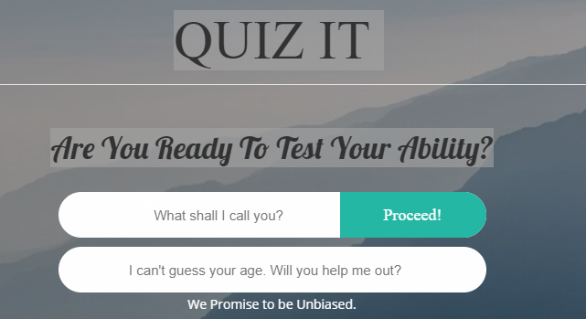

### Engaging:

Draws the user into the interaction and is pleasant and satisfying to use. As evident from the Child’s page layout the elegant UI design assures the success of apps and websites by making the user experience positive and engaging. The Child’s background image is appealing and the background music is soothing and attractive for the child to do the quiz with a smile.

The Contrast is such that all elements are easy to read and engage. This is especially true as designers work to make interfaces accessible to more people; those suffering from even minor vision loss often struggle with low-contrast visuals.

There is no distortion in the UI that impedes user in exiting the app.

The text size is soothing as the user be it adult or child skim more than read, making size and weight of the text very important part of the project. The different Fonts size and for different user are engaging enough to draw the attention of the user. If the user will access an interface on the different devices and screens, it will not affect the UI and will be soothing as they are doing in the laptop.

Screen resolution: For optimum UI, many applications and interfaces need to work on screens with varying resolutions. Good resolution impacts readability and usability, making the UI negative but in our design the app is self-adaptive and the

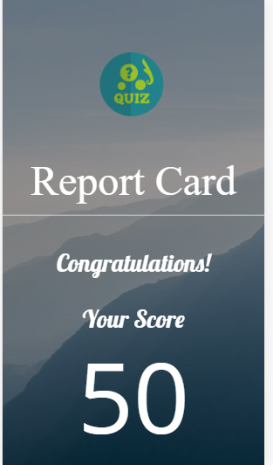 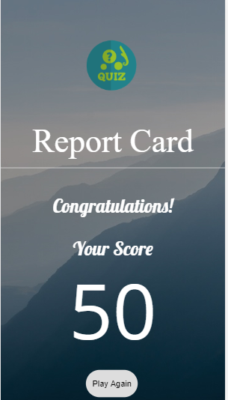

IPhone 6/7/8 resolution Pixel2 resolution

### Effective:

The user took less time to correctly find the correct way to enter the age in the text field and pressed enter button which took the user to the next screen.

The user efficiently got entered his age and was able to go to the next screen without any problem.

The user was able to recognize the screen fairly quickly and selected the topics that were displayed to him

The user was an adult, so he had to enter his answer in a text box which he did correctly but was confused about submitting the answer

### (d)Efficient:

The user took less time to correctly find the correct way to enter the age in the text field and pressed enter button which took the user to the next screen.

All topics are displayed, takes only one click to select topic. If we have more topics available, a dropdown list is available in the website so that user can select more than one topics.

# RESPONSIBILITIES AND INDIVIDUAL CONTRIBUTIONS: -

|  |  |
| --- | --- |
| **Module** | **Team Member** |
| **Usability Testing** | Prototype 1 (Ashmeet Singh, Gursimran Singh, Ufuoma Ubor)  Prototype 2 (Ashmeet Singh, Gursimran Singh, Ufuoma Ubor)  Prototype 3 (Gursimran Singh, Ufuoma Ubor) |
| **Analytical Evaluation** | Prototype 1 (Manpreet Singh, Gurjot Singh)  Prototype 2 (Ashmeet Singh, Gursimran Singh)  Prototype 3 (Gursimran Singh, Ufuoma Ubor) |

# Bibliography

|  |  |
| --- | --- |
| [1] | R. Jayakumar, "Lecture Slides Requirements Gathering," January 2019. [Online]. |
| [2] | "Personas in Design Thinking," Teo Yu Siang and Interaction Design Foundation, 2019. [Online]. Available: https://www.interaction-design.org/literature/article/personas-why-and-how-you-should-use-them. |